Aim: Data Visualization for the selected dataset using Matplotlib and Seaborn
import seaborn as sns
import matplotlib.pyplot as plt
import pandas as pd
import numpy as np

sns.set(style="whitegrid")

df = sns.load_dataset("tips")
df.head()

Ouput:
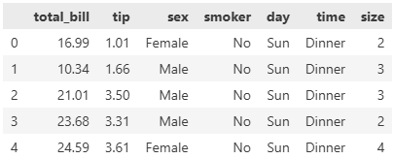

plt.figure()
sns.scatterplot(
data=df,
x="total_bill",
y="tip",
hue="sex",
style="time"
)
plt.show()

Ouput:
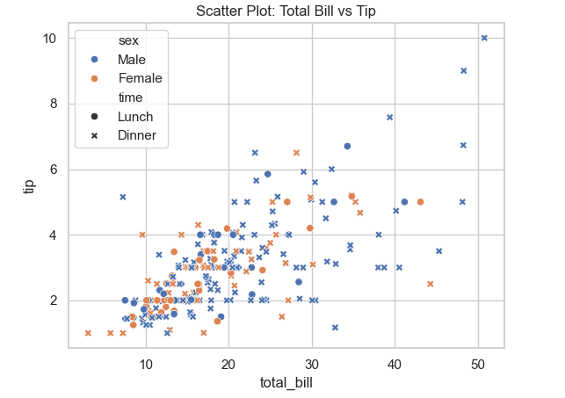
The scatter plot reveals interesting patterns in tipping behavior across different genders and meal times.
plt.figure()
sns.barplot(
data=df,
x="day",
y="total_bill",
hue="sex"
)
plt.show()

Ouput:
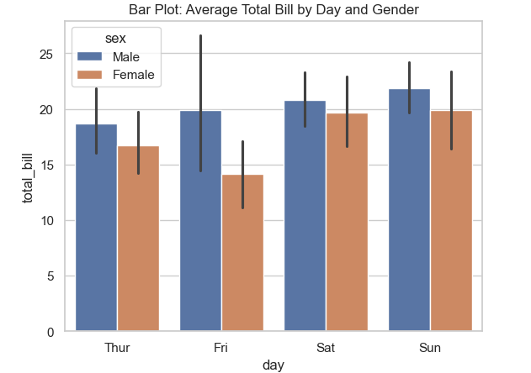
The bar plot clearly shows the average spending differences between male and female customers across days of the week.
plt.figure()
sns.violinplot(
data=df,
x="day",
y="total_bill",
hue="sex",
split=True
)
plt.show()

Ouput:
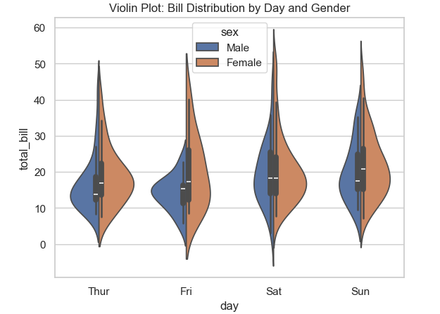
The violin plot provides a detailed view of the total bill distribution, highlighting gender-based spending patterns each day.

corr = df.corr(numeric_only=True)
corr

Ouput:
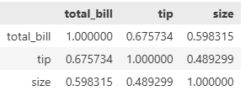
The correlation matrix helps identify key relationships between numerical variables like total bill, tip, and table size.

plt.figure()
sns.heatmap(
corr,
annot=True,
cmap="coolwarm",
linewidths=0.5
)
plt.show()

Ouput:

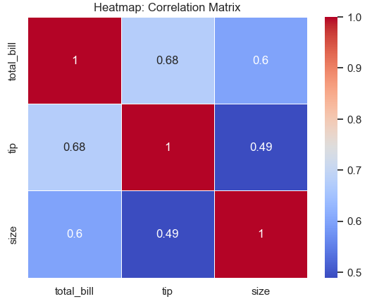
The heatmap visually emphasizes the strength and direction of correlations between numerical features in the dataset.

plt.figure()
sns.swarmplot(
data=df,
x="day",
y="total_bill"
)
plt.show()

Ouput:
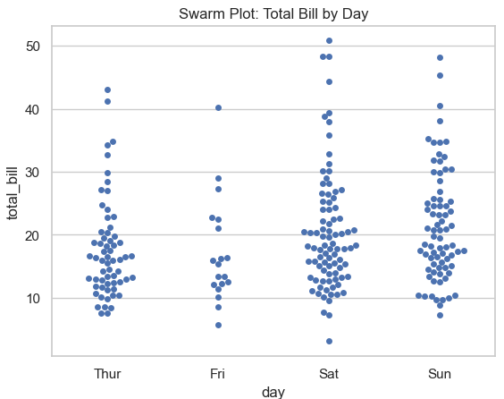
The swarm plot offers an alternative view of daily spending by showing individual data points without overlapping.

Conclusion
Successfully demonstrated how different visualization techniques can reveal distinct insights about customer tipping behavior and spending patterns via Seaborn. The visualizations clearly show that total bill amount correlates strongly with tip size, while gender and meal time also play meaningful roles in spending distributions across days of the week.

